Leadership Compass Worksheet

Read the following statements. Put a check next to the statements that apply to you. When you are done, the facilitator will share the answer key with you to reveal your leadership style.

___ 1. I make space for everyone to be heard and to be engaged in the work
___ 2. I am a good listener and have strong facilitation skills
___ 3. I avoid conflicts
___ 4. I pay attention to the values of a group
___ 5. I focus on process instead of goals
___ 6. I am sensitive to people’s individual feelings
___ 7. I don’t like to take risks
___ 8. I have excellent planning and documentation skills
___ 9. I am very detail oriented
___ 10. I have a tendency to over analyze
___ 11. I am sometimes insensitive to people’s passions
___ 12. I high standards for work products
___ 13. I sometimes have a hard time making decisions when faced with many options
___ 14. I like challenges
___ 15. I persevere through obstacles
___ 16. I sometimes overlook process
___ 17. I am decisive
___ 18. I am good at organizing and motivating people for action
___ 19. I am often argumentative
___ 20. I am often impatient
___ 21. I am good at seeing the big picture
___ 22. I sometimes lose sight of process and details
___ 23. I am innovative
___ 24. I like problems solving
___ 25. I have difficulty sustaining passion after initial enthusiasm dies down
___ 26. I am willing to experiment
___ 27. I struggle to follow through

Leadership Compass Handout
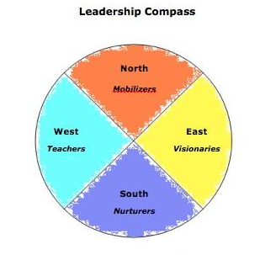

What’s your leadership style?
What’s the leadership style of other people on the team?
Which groups of traits best represents how you like to work?
Most people have elements of more than one style but there is one dominant style. No trait is better or worse than another trait, just a different style.

NORTH (Mobilizer) (numbers 14-20)
- Likes challenges
- Perseveres through obstacles
- May overlook process
- Decisive
- Good at organizing and motivating people for action
- May be argumentative
- May be impatient

EAST (Visionary) (numbers 21-27)
- Good at seeing the big picture
- May lose sight of process and details
- Innovative
- Likes problems solving
- Has difficulty sustaining passion after initial enthusiasm wanes away
- Willing to experiment
- Struggles to follow through

SOUTH (Nurturer) (numbers 1-7)
- Makes space for everyone to be heard and engaged in the work
- Good listening and facilitation skills
- Avoids conflicts
- Observant of group values
- Focuses on process instead of goals
- Doesn’t like to take risks
- Sensitive to people’s individual feelings

WEST (Teacher) (numbers 7-13)
- Excellent planning and documentation skills
- May be averse to risk
- Very detail oriented
- Tendency to overanalyze
- Maybe insensitive to people’s passions
- High standards for work product
- May have a hard time making decisions when faced with many options

